Chapter 19
Learning from Examples

In which we describe agents that can improve their behavior through diligent study of past experiences and predictions about the future.

An agent is **learning** if it improves its performance after making observations about the world. Learning can range from the trivial, such as jotting down a shopping list, to the profound, as when Albert Einstein inferred a new theory of the universe. When the agent is a computer, we call it **machine learning**: a computer observes some data, builds a **model** based on the data, and uses the model as both a **hypothesis** about the world and a piece of software that can solve problems.

Why would we want a machine to learn? Why not just program it the right way to begin with? There are two main reasons. First, the designers cannot anticipate all possible future situations. For example, a robot designed to navigate mazes must learn the layout of each new maze it encounters; a program for predicting stock market prices must learn to adapt when conditions change from boom to bust. Second, sometimes the designers have no idea how to program a solution themselves. Most people are good at recognizing the faces of family members, but they do it subconsciously, so even the best programmers don’t know how to program a computer to accomplish that task, except by using machine learning algorithms.

In this chapter, we interleave a discussion of various model classes—decision trees (**Section 19.3**), linear models (**Section 19.6**), nonparametric models such as nearest neighbors (**Section 19.7**), ensemble models such as random forests (**Section 19.8**)—with practical advice on building machine learning systems (**Section 19.9**), and discussion of the theory of machine learning (**Sections 19.1 to 19.5**).

19.1 Forms of Learning
Any component of an agent program can be improved by machine learning. The improvements, and the techniques used to make them, depend on these factors:
- Which component is to be improved.
- What prior knowledge the agent has, which influences the model it builds.
- What data and feedback on that data is available.
Chapter 2 described several agent designs. The components of these agents include:
- A direct mapping from conditions on the current state to actions.
- A means to infer relevant properties of the world from the percept sequence.
- Information about the way the world evolves and about the results of possible actions the agent can take.
- Utility information indicating the desirability of world states.
- Action-value information indicating the desirability of actions.
- Goals that describe the most desirable states.
- A problem generator, critic, and learning element that enable the system to improve.
Each of these components can be learned. Consider a self-driving car agent that learns by observing a human driver. Every time the driver brakes, the agent might learn a condition–action rule for when to brake (component 1). By seeing many camera images that it is told contain buses, it can learn to recognize them (component 2). By trying actions and observing the results—for example, braking hard on a wet road—it can learn the effects of its actions (component 3). Then, when it receives complaints from passengers who have been thoroughly shaken up during the trip, it can learn a useful component of its overall utility function (component 4).
The technology of machine learning has become a standard part of software engineering. Any time you are building a software system, even if you don’t think of it as an AI agent, components of the system can potentially be improved with machine learning. For example, software to analyze images of galaxies under gravitational lensing was speeded up by a factor of 10 million with a machine-learned model (Hezaveh et al., 2017), and energy use for cooling data centers was reduced by 40% with another machine-learned model (Gao, 2014). Turing Award winner David Patterson and Google AI head Jeff Dean declared the dawn of a “Golden Age” for computer architecture due to machine learning (Dean et al., 2018).
We have seen several examples of models for agent components: atomic, factored, and relational models based on logic or probability, and so on. Learning algorithms have been devised for all of these.
This chapter assumes little prior knowledge on the part of the agent: it starts from scratch and learns from the data. In Section 21.7.2 we consider transfer learning, in which knowledge from one domain is transferred to a new domain, so that learning can proceed faster with less data. We do assume, however, that the designer of the system chooses a model framework that can lead to effective learning.
Going from a specific set of observations to a general rule is called induction; from the observations that the sun rose every day in the past, we induce that the sun will come up tomorrow. This differs from the deduction we studied in Chapter 7 because the inductive conclusions may be incorrect, whereas deductive conclusions are guaranteed to be correct if the premises are correct.
This chapter concentrates on problems where the input is a factored representation—a vector of attribute values. It is also possible for the input to be any kind of data structure, including atomic and relational.
When the output is one of a finite set of values, such as sunny/cloudy/rainy or true/false, the learning problem is called classification. When it is a number, such as tomorrow’s temperature, measured either as an integer or a real number, the learning problem has the admittedly obscure name regression.
There are three types of feedback that can accompany the inputs, and that determine the three main types of learning:
- In supervised learning the agent observes input-output pairs and learns a function that maps from input to output. For example, the inputs could be camera images, each one accompanied by an output saying “bus” or “pedestrian,” etc. An output like this is called a label. The agent learns a function that, when given a new image, predicts the appropriate label. In the case of braking actions (component 1 above), an input is the current state—speed and direction of the car, road condition—and an output is the distance it took to stop. In this case a set of output values can be obtained by the agent from its own percepts after the fact; the environment is the teacher, and the agent learns a function that maps states to stopping distance.
- In unsupervised learning the agent learns patterns in the input without any explicit feedback. The most common unsupervised learning task is clustering: detecting potentially useful clusters of input examples. For example, when shown millions of images taken from the Internet, a computer vision system can identify a large cluster of similar images which an English speaker would call “cats.”
- In reinforcement learning the agent learns from a series of reinforcements: rewards and punishments. For example, at the end of a chess game the agent is told that it has won—a reward—or lost—a punishment. It is up to the agent to decide which of the actions prior to the reinforcement were most responsible for it, and to alter its actions to aim towards more rewards in the future.

19.2 Supervised Learning
More formally, the task of supervised learning is this:
Given a training set of (N) example input–output pairs
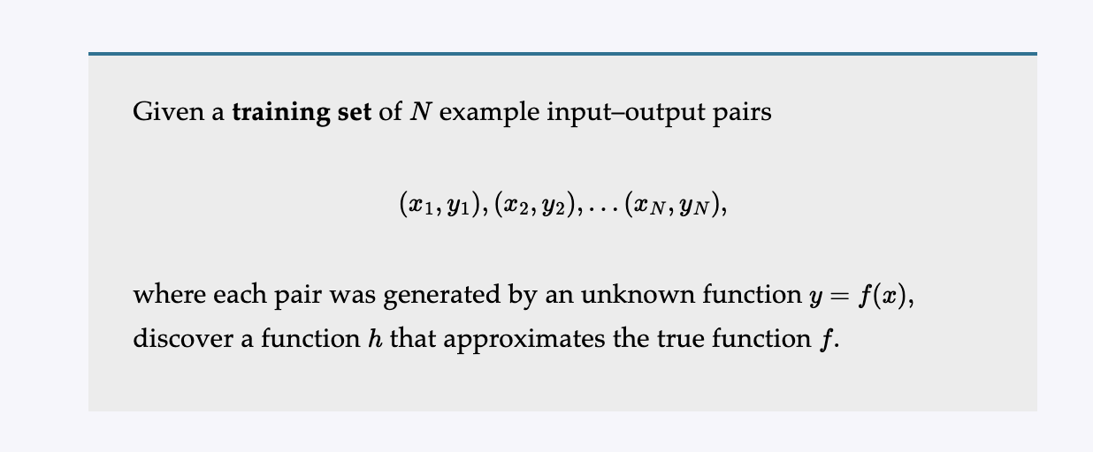
where each pair was generated by an unknown function (y=f(x)), discover a function (h) that approximates the true function (f).
The function (h) is called a hypothesis about the world. It is drawn from a hypothesis space (H) of possible functions. For example, the hypothesis space might be the set of polynomials of degree 3; or the set of Javascript functions; or the set of 3-SAT Boolean logic formulas.
With alternative vocabulary, we can say that (h) is a model of the data, drawn from a model class (H), or we can say a function drawn from a function class. We call the output (y_i) the ground truth—the true answer we are asking our model to predict.
How do we choose a hypothesis space? We might have some prior knowledge about the process that generated the data. If not, we can perform exploratory data analysis: examining the data with statistical tests and visualizations—histograms, scatter plots, box plots—to get a feel for the data, and some insight into what hypothesis space might be appropriate. Or we can just try multiple hypothesis spaces and evaluate which one works best.
How do we choose a good hypothesis from within the hypothesis space? We could hope for a consistent hypothesis: an (h) such that each (x_i) in the training set has (h(x_i)=y_i). With continuous-valued outputs we can’t expect an exact match to the ground truth; instead we look for a best-fit function for which each (h(x_i)) is close to (y_i) (in a way that we will formalize in Section 19.4.2).
The true measure of a hypothesis is not how it does on the training set, but rather how well it handles inputs it has not yet seen. We can evaluate that with a second sample of ((x_i,y_i)) pairs called a test set. We say that (h) generalizes well if it accurately predicts the outputs of the test set.
Figure 19.1 shows that the function (h) that a learning algorithm discovers depends on the hypothesis space (H) it considers and on the training set it is given. Each of the four plots in the top row have the same training set of 13 data points in the ((x,y)) plane. The four plots in the bottom row have a second set of 13 data points; both sets are representative of the same unknown function (f(x)). Each column shows the best-fit hypothesis (h) from a different hypothesis space:
- Column 1: Straight lines; functions of the form (h(x)=w_1x+w_0). There is no line that would be a consistent hypothesis for the data points.
- Column 2: Sinusoidal functions of the form (h(x)=w_1x+\sin(w_0x)). This choice is not quite consistent, but fits both data sets very well.
- Column 3: Piecewise-linear functions where each line segment connects the dots from one data point to the next. These functions are always consistent.
- Column 4: Degree-12 polynomials,
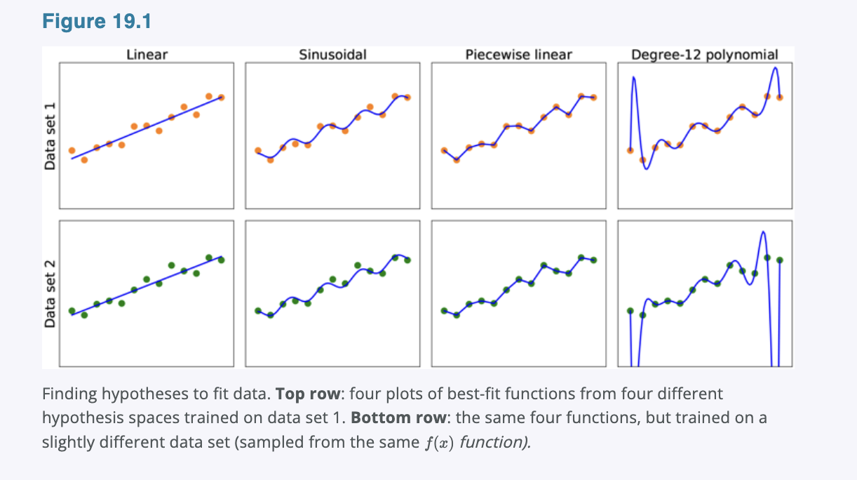These are consistent: we can always get a degree-12 polynomial to perfectly fit 13 distinct points. But just because the hypothesis is consistent does not mean it is a good guess.

Figure 19.1
Finding hypotheses to fit data. Top row: four plots of best-fit functions from four different hypothesis spaces trained on data set 1. Bottom row: the same four functions, but trained on a slightly different data set sampled from the same (f(x)) function.
One way to analyze hypothesis spaces is by the bias they impose, regardless of the training data set, and the variance they produce from one training set to another.
By bias we mean, loosely, the tendency of a predictive hypothesis to deviate from the expected value when averaged over different training sets. Bias often results from restrictions imposed by the hypothesis space. For example, the hypothesis space of linear functions induces a strong bias: it only allows functions consisting of straight lines. If there are any patterns in the data other than the overall slope of a line, a linear function will not be able to represent those patterns. We say that a hypothesis is underfitting when it fails to find a pattern in the data. On the other hand, the piecewise linear function has low bias; the shape of the function is driven by the data.
By variance we mean the amount of change in the hypothesis due to fluctuation in the training data. The two rows of Figure 19.1 represent data sets that were each sampled from the same (f(x)) function. The data sets turned out to be slightly different. For the first three columns, the small difference in the data set translates into a small difference in the hypothesis. We call that low variance. But the degree-12 polynomials in the fourth column have high variance: look how different the two functions are at both ends of the (x)-axis. Clearly, at least one of these polynomials must be a poor approximation to the true (f(x)). We say a function is overfitting the data when it pays too much attention to the particular data set it is trained on, causing it to perform poorly on unseen data.
Often there is a bias–variance tradeoff: a choice between more complex, low-bias hypotheses that fit the training data well and simpler, low-variance hypotheses that may generalize better. Albert Einstein said in 1933, “the supreme goal of all theory is to make the irreducible basic elements as simple and as few as possible without having to surrender the adequate representation of a single datum of experience.” In other words, Einstein recommends choosing the simplest hypothesis that matches the data. This principle can be traced further back to the 14th-century English philosopher William of Ockham. His principle that “plurality [of entities] should not be posited without necessity” is called Ockham’s razor because it is used to “shave off” dubious explanations.
Defining simplicity is not easy. It seems clear that a polynomial with only two parameters is simpler than one with thirteen parameters. We will make this intuition more precise in Section 19.3.4. However, in Chapter 21 we will see that deep neural network models can often generalize quite well, even though they are very complex—some of them have billions of parameters. So the number of parameters by itself is not a good measure of a model’s fitness. Perhaps we should be aiming for “appropriateness,” not “simplicity” in a model class. We will consider this issue in Section 19.4.1.
Which hypothesis is best in Figure 19.1? We can’t be certain. If we knew the data represented, say, the number of hits to a Web site that grows from day to day but also cycles depending on the time of day, then we might favor the sinusoidal function. If we knew the data was definitely not cyclic but had high noise, that would favor the linear function.
In some cases, an analyst is willing to say not just that a hypothesis is possible or impossible, but rather how probable it is. Supervised learning can be done by choosing the hypothesis (h^*) that is most probable given the data:
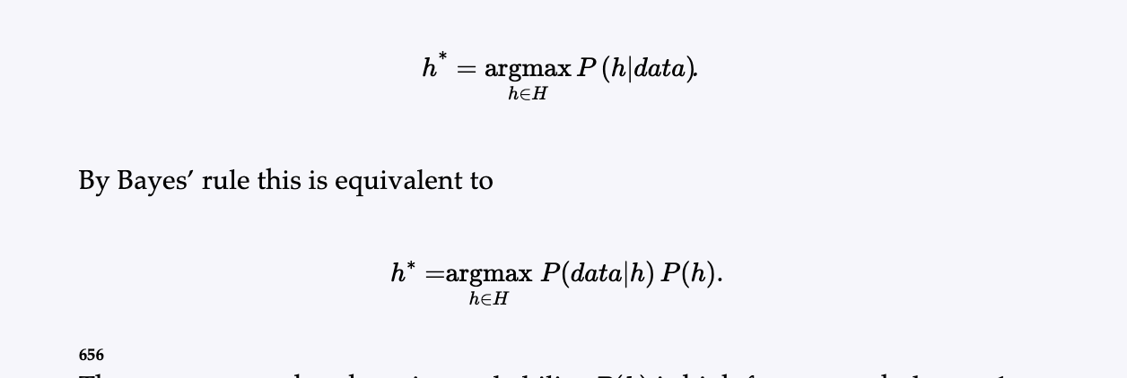
Then we can say that the prior probability (P(h)) is high for a smooth degree-1 or -2 polynomial and lower for a degree-12 polynomial with large, sharp spikes. We allow unusual-looking functions when the data say we really need them, but we discourage them by giving them a low prior probability.
Why not let (H) be the class of all computer programs, or all Turing machines? The problem is that there is a tradeoff between the expressiveness of a hypothesis space and the computational complexity of finding a good hypothesis within that space. For example, fitting a straight line to data is an easy computation; fitting high-degree polynomials is somewhat harder; and fitting Turing machines is undecidable. A second reason to prefer simple hypothesis spaces is that presumably we will want to use (h) after we have learned it, and computing (h(x)) when (h) is a linear function is guaranteed to be fast, while computing an arbitrary Turing machine program is not even guaranteed to terminate.
For these reasons, most work on learning has focused on simple representations. In recent years there has been great interest in deep learning (Chapter 21), where representations are not simple but where the (h(x)) computation still takes only a bounded number of steps to compute with appropriate hardware.
We will see that the expressiveness–complexity tradeoff is not simple: it is often the case, as we saw with first-order logic in Chapter 8, that an expressive language makes it possible for a simple hypothesis to fit the data, whereas restricting the expressiveness of the language means that any consistent hypothesis must be complex.

19.2.1 Example Problem: Restaurant Waiting
We will describe a sample supervised learning problem in detail: the problem of deciding whether to wait for a table at a restaurant. This problem will be used throughout the chapter to demonstrate different model classes. For this problem the output, (y), is a Boolean variable that we will call WillWait; it is true for examples where we do wait for a table. The input, (x), is a vector of ten attribute values, each of which has discrete values:
- Alternate: whether there is a suitable alternative restaurant nearby.
- Bar: whether the restaurant has a comfortable bar area to wait in.
- Fri/Sat: true on Fridays and Saturdays.
- Hungry: whether we are hungry right now.
- Patrons: how many people are in the restaurant (values are None, Some, and Full).
- Price: the restaurant’s price range ($, $$, $$$).
- Raining: whether it is raining outside.
- Reservation: whether we made a reservation.
- Type: the kind of restaurant (French, Italian, Thai, or burger).
- WaitEstimate: host’s wait estimate: 0–10, 10–30, 30–60, or >60 minutes.
A set of 12 examples, taken from the experience of one of us (SR), is shown in Figure 19.2. Note how skimpy these data are: there are
[
2^6 \times 3^2 \times 4^2 = 9{,}216
]
possible combinations of values for the input attributes, but we are given the correct output for only 12 of them; each of the other 9,204 could be either true or false; we don’t know. This is the essence of induction: we need to make our best guess at these missing 9,204 output values, given only the evidence of the 12 examples.

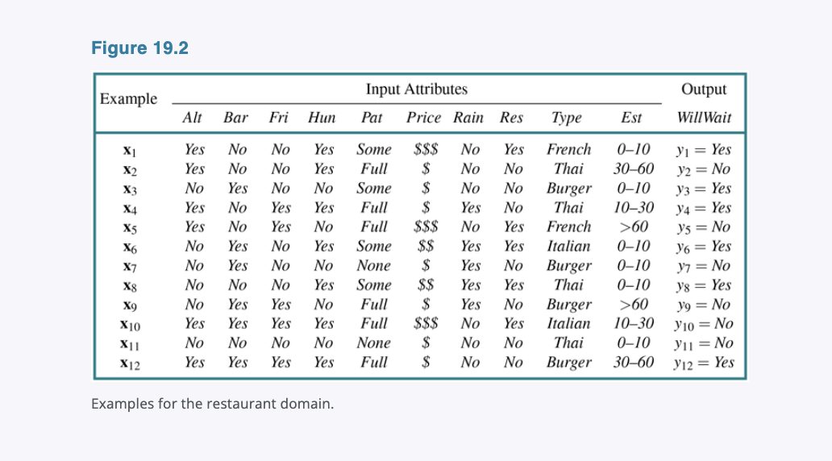

19.3 Learning Decision Trees
A decision tree is a representation of a function that maps a vector of attribute values to a single output value—a “decision.” A decision tree reaches its decision by performing a sequence of tests, starting at the root and following the appropriate branch until a leaf is reached. Each internal node in the tree corresponds to a test of the value of one of the input attributes, the branches from the node are labeled with the possible values of the attribute, and the leaf nodes specify what value is to be returned by the function.
In general, the input and output values can be discrete or continuous, but for now we will consider only inputs consisting of discrete values and outputs that are either true (a positive example) or false (a negative example). We call this Boolean classification. We will use (j) to index the examples ((\mathbf{x}j) is the input vector for the (j)th example and (y_j) is the output), and (x{j,i}) for the (i)th attribute of the (j)th example.
The tree representing the decision function that SR uses for the restaurant problem is shown in Figure 19.3. Following the branches, we see that an example with Patrons = Full and WaitEstimate = 0–10 will be classified as positive (i.e., yes, we will wait for a table).
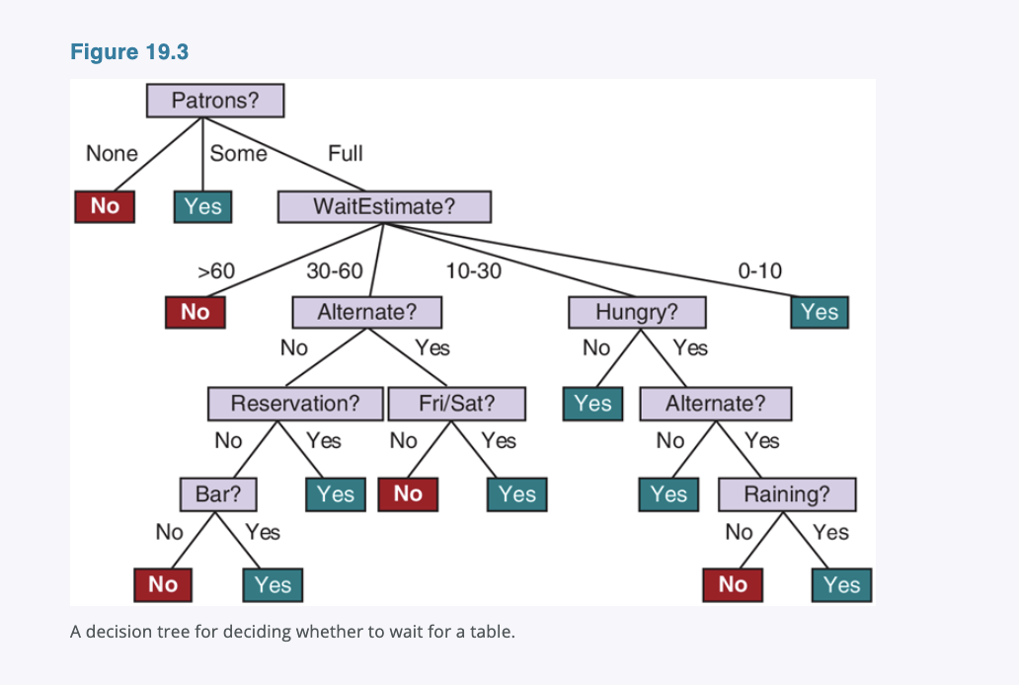

19.3.1 Expressiveness of Decision Trees
A Boolean decision tree is equivalent to a logical statement of the form:
[
Output \Leftrightarrow (Path_1 \lor Path_2 \lor \cdots),
]
where each (Path_i) is a conjunction of the form
[
(A_m = v_x \land A_n = v_y \land \cdots)
]
of attribute-value tests corresponding to a path from the root to a true leaf. Thus, the whole expression is in disjunctive normal form, which means that any function in propositional logic can be expressed as a decision tree.
For many problems, the decision tree format yields a nice, concise, understandable result. Indeed, many “How To” manuals (e.g., for car repair) are written as decision trees. But some functions cannot be represented concisely. For example, the majority function, which returns true if and only if more than half of the inputs are true, requires an exponentially large decision tree, as does the parity function, which returns true if and only if an even number of input attributes are true. With real-valued attributes, the function
[
y > A_1 + A_2
]
is hard to represent with a decision tree because the decision boundary is a diagonal line, and all decision tree tests divide the space up into rectangular, axis-aligned boxes. We would have to stack a lot of boxes to closely approximate the diagonal line. In other words, decision trees are good for some kinds of functions and bad for others.
Is there any kind of representation that is efficient for all kinds of functions? Unfortunately, the answer is no—there are just too many functions to be able to represent them all with a small number of bits. Even just considering Boolean functions with (n) Boolean attributes, the truth table will have (2^n) rows, and each row can output true or false, so there are
[
2^{2^n}
]
different functions. With 20 attributes there are
[
2^{1{,}048{,}576} \approx 10^{300{,}000}
]
functions, so if we limit ourselves to a million-bit representation, we can’t represent all these functions.

19.3.2 Learning Decision Trees from Examples
We want to find a tree that is consistent with the examples in Figure 19.2 and is as small as possible. Unfortunately, it is intractable to find a guaranteed smallest consistent tree. But with some simple heuristics, we can efficiently find one that is close to the smallest. The LEARN-DECISION-TREE algorithm adopts a greedy divide-and-conquer strategy: always test the most important attribute first, then recursively solve the smaller subproblems that are defined by the possible results of the test. By “most important attribute,” we mean the one that makes the most difference to the classification of an example. That way, we hope to get to the correct classification with a small number of tests, meaning that all paths in the tree will be short and the tree as a whole will be shallow.
Figure 19.4(a) shows that Type is a poor attribute, because it leaves us with four possible outcomes, each of which has the same number of positive as negative examples. On the other hand, in (b) we see that Patrons is a fairly important attribute, because if the value is None or Some, then we are left with example sets for which we can answer definitively (No and Yes, respectively). If the value is Full, we are left with a mixed set of examples. There are four cases to consider for these recursive subproblems:
- If the remaining examples are all positive (or all negative), then we are done: we can answer Yes or No. Figure 19.4(b) shows examples of this happening in the None and Some branches.
- If there are some positive and some negative examples, then choose the best attribute to split them. Figure 19.4(b) shows Hungry being used to split the remaining examples.

